

CONVEYOR TRANSFER CHUTE ANALYSIS

Prepared for

ABC Mining
Perth
Australia

Prepared by
Helix Technologies Pty Ltd
PO Box 610
Morley WA 6943
Perth
Australia
Tel +61 8 9275 0635
Email: helix@helixtech.com.au

29/07/2026

Transfer Chute CV4E-CV5

Table of Contents
1 Introduction 3
2 Conveyor Details 3
3 Basic Conveyor and Chute Layout 3
4 Belt Transition Trough to Flat 4
4.1 Trough idler Calculated Material Cross-section 4
4.2 Transition idler Calculated Material Cross-section 5
4.3 Belt Transition Geometry 6
5 Theoretical Discharge Trajectory 7
5.1 Discharge Trajectory at 3.0m/s and 0 degree incline 7
6 DEM Model Inputs 8
7 DEM Calculations Run 1 14
8 Particle Trace 23
8.1 Particle number 1366 Trace 23
9 Summary and Conclusions 25
10 Reference Drawings and Documents 25
11 Disclaimer 25
12 Appendices 26
12.1 Particle Trace Reports 26
12.2 Helix DEM Model movie file download links 26

Introduction
Conveyor CV4E has a transfer chute at the discharge pulley onto conveyor CV5. The transfer chute has a rock-box arrangement and a transfer angle of 72.253 degrees between belt centre lines. The material is primary crushed Copper ore with 75mm lump size.
Helix Technologies have been contracted to build a Discrete Element Method (DEM) model of the transfer and to run this model to determine the predicted trajectory and impact of the material in the chute.
The software used to make this model is the Helix DEM Chute design program, details of which are available from www.helixtech.com.au
This report details the results of the DEM modelling.

Conveyor Details
The feed conveyor CV4E is a 1066mm wide belt troughed at 35 degrees. Belt speed is 3.0m/s and approach angle at the discharge is 0 degrees.

The receiving conveyor CV5 is a 914mm wide belt troughed at 35 degrees. Belt speed is 4.0m/s and incline angle at the loading point is 0 degrees. CV5 has a loading hopper before the transfer chute from CV4E and the design capacity from this hopper is 320tph of copper ore. The transfer is required to load onto a partly loaded CV5 belt.

Basic Conveyor and Chute Layout
The CV4E conveyor belt is 1066mm wide running at 3.0m/s. The discharge pulley is 796mm diameter over lagging. There is a rock box with hard metal wear bar lip along the front edge of the transfer. The top of the chute box has an angled plate with inspection door.
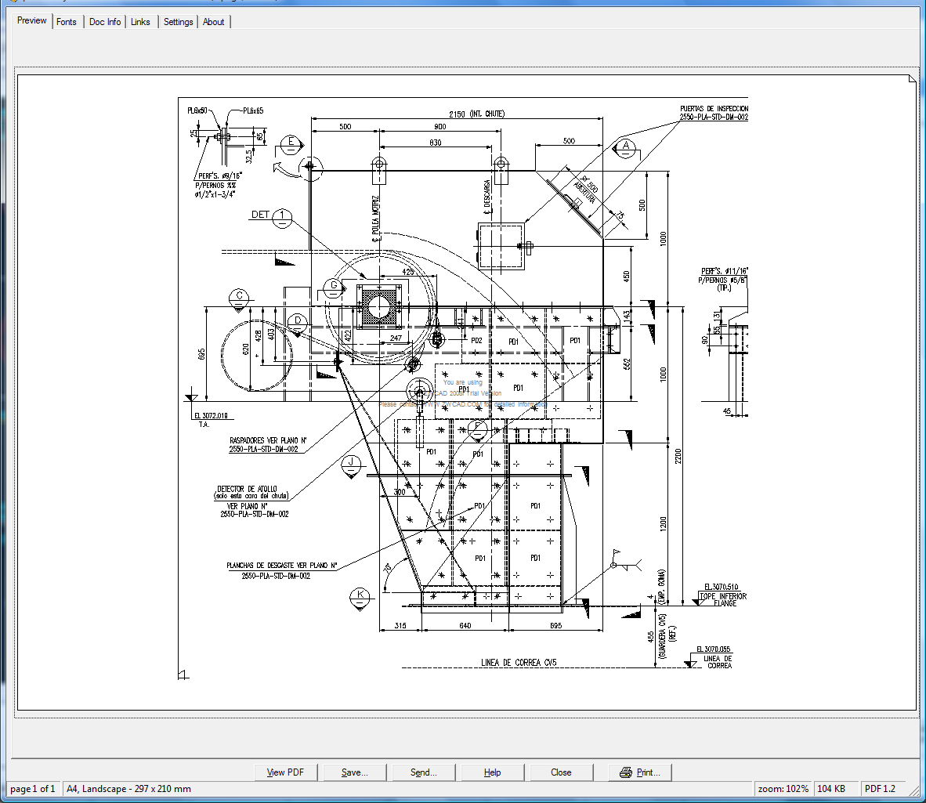
Transfer chute drawing

Belt Transition Trough to Flat
The idler trough angle is 35 degrees with a centre roll face width of 396mm. Idler spacing is 900mm and it is assumed a single transition idler of 17.5 degree trough is installed over a total transition length of 1.8m.

Trough idler Calculated Material Cross-section
The following drawing is calculated and drawn from the Helix delta-T Conveyor design software. A bulk density of 1600kg/m3 and a surcharge of 25 degrees have been used.

Capacity 1600tph, Trough 35 degree

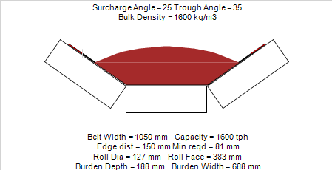

Capacity is 1600tph. Burden Depth is 188mm.

Transition idler Calculated Material Cross-section
The following drawing is calculated and drawn from the Helix delta-T Conveyor design software at an intermediate and at the last idler before the discharge pulley.

Capacity 1600tph, Trough 17.5 degree
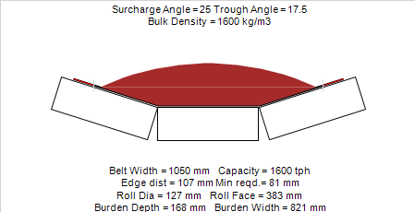

Belt Transition Geometry

Helix DEM model transition is shown below:

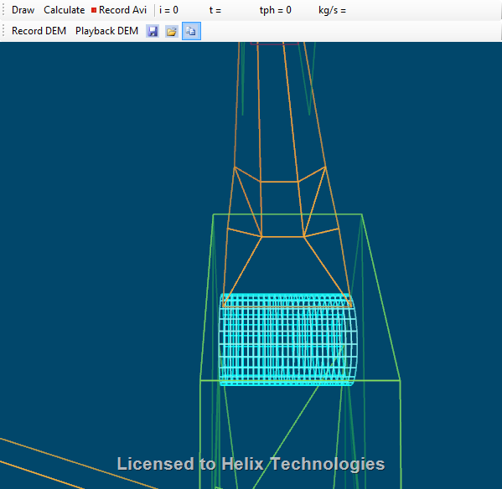

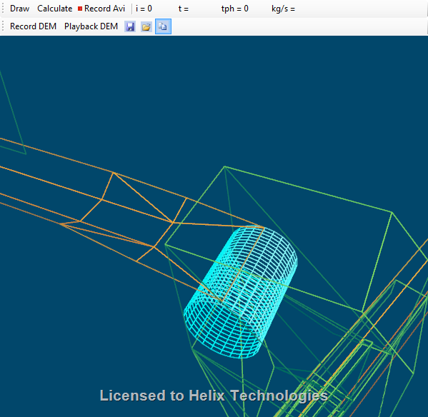
Note the constant width centre section of the transition.

Theoretical Discharge Trajectory
The following calculations show the theoretical discharge trajectory calculated using the CEMA methods and performed using the Helix delta-T software.

Discharge Trajectory at 3.0m/s and 0 degree incline
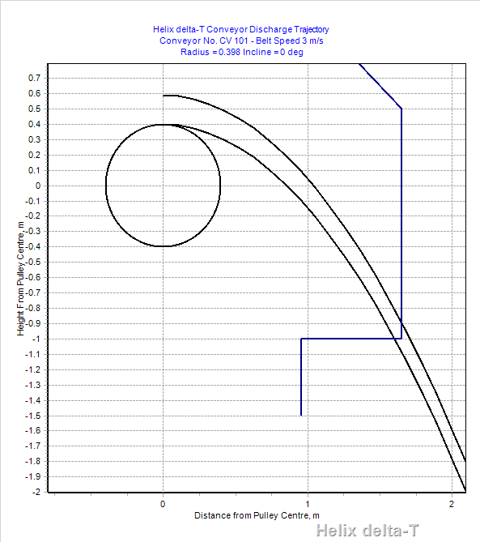

The trajectory calculation above is for the belt running at 3.0m/s and a burden depth of 188mm. The belt incline angle is zero at transition. The rock box shelf is shown in position.

DEM Model Inputs

This model has been run using 75mm – 50mm particle.

DEM Input Details
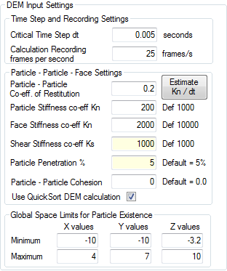

Material Feed CV4E
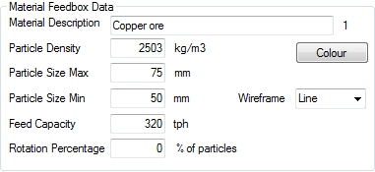
Particle density is calculated from a bulk density of 1600kg/m3 using a ‘Random Close Packing’ factor 0.64. (1600/ 0.64 = 2503)
Two Feed boxes are used, one for the 320tph on CV5 and one for the 1600tph on CV4E.

Particle Velocity Colours
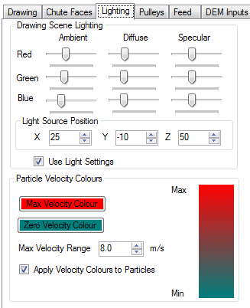
Particle velocities are drawn as green for slow velocity and red as 8m/s with orange colour somewhere in between.

Shaded model
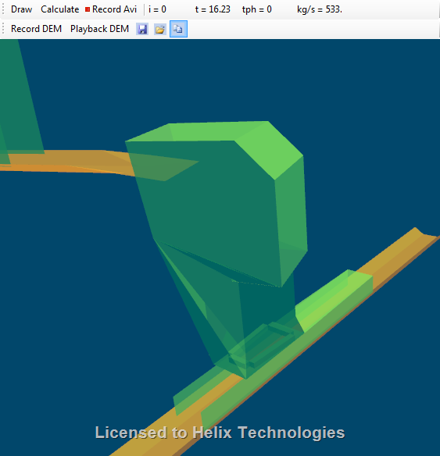

Wireframe DEM model
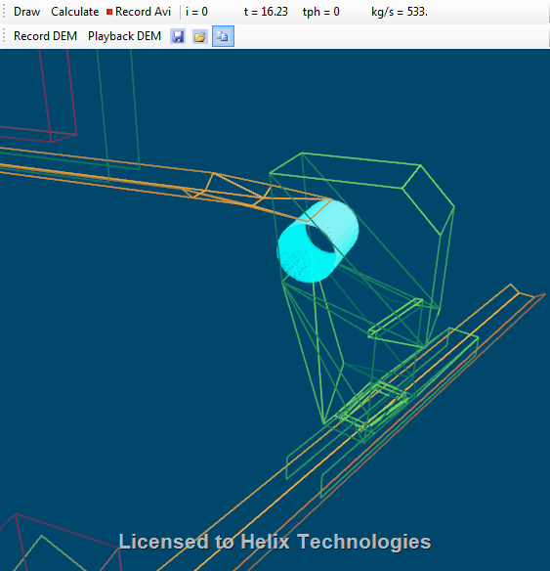

Plan View through chute.
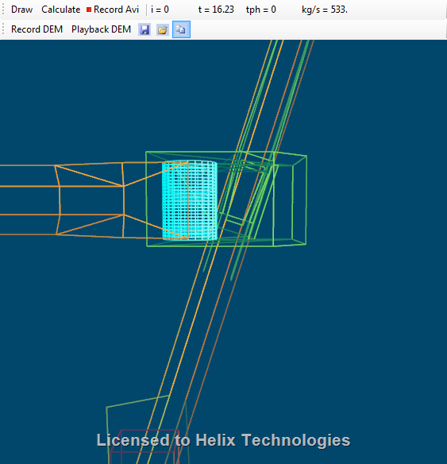

Plan View from pulley downwards.
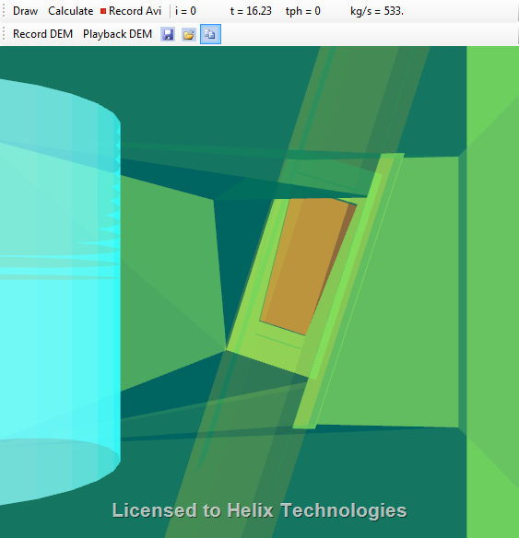

DEM Calculations Run 1
This calculation was undertaken with the chute drawn as per the drawings supplied. The initial calculations show the flow of material in the transfer is adequate. Loading onto the partly loaded CV5 can be seen to create some turbulence in the loading area. The material is well contained by the loading skirts.
See Video marked “Helix Chute ABC Mining CV4E-CV5 rev 01.avi”

Right Side View
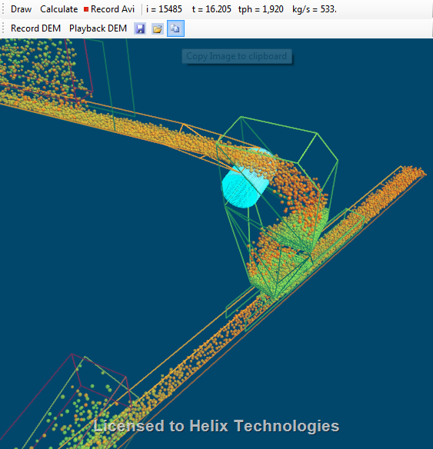

Isometric view of model running at 320tph plus 1600tph. Green particles are moving slowly and red particles moving fast.

Side View
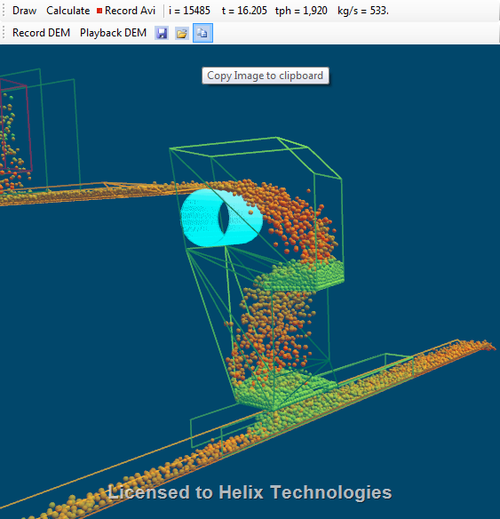

Front View

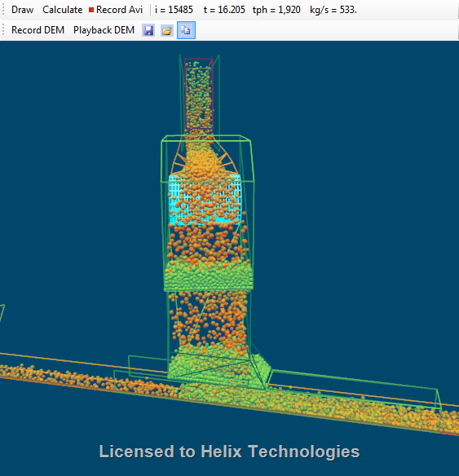
Note material loading onto partially loaded belt. The length of the loading slot is relatively long and this means that the 1600tph is spread over a reasonable distance when it falls onto the partially loaded belt. Note build up of material in upper and lower rock boxes

Close up view of loading portion

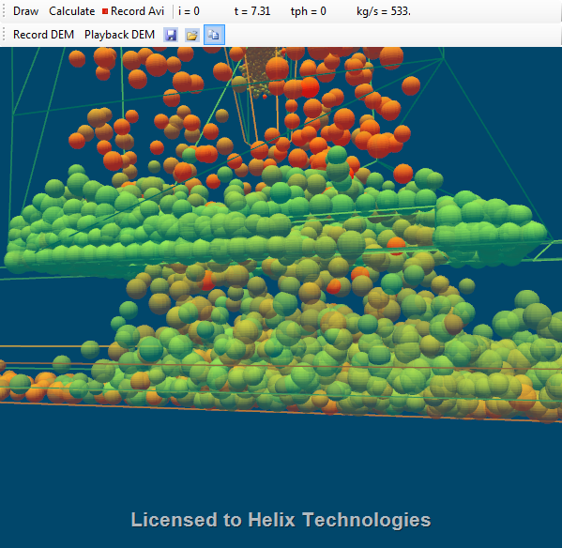
Note faster moving orange colour particles coming in from left of screen view collide with particles falling vertically from Vee slot.

Top View of Vee slot rock box
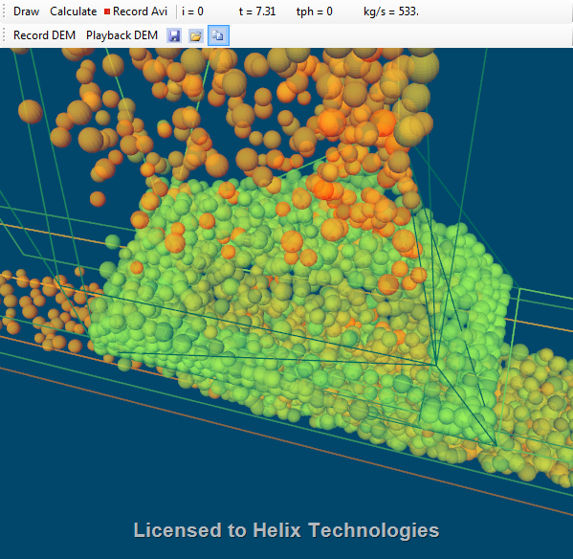

Top View of transfer

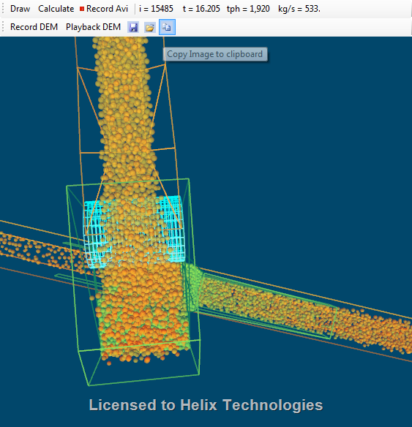
Slightly more material on left side of CV5

Note there is slightly more material on the left side of the CV5 belt

Left Side View
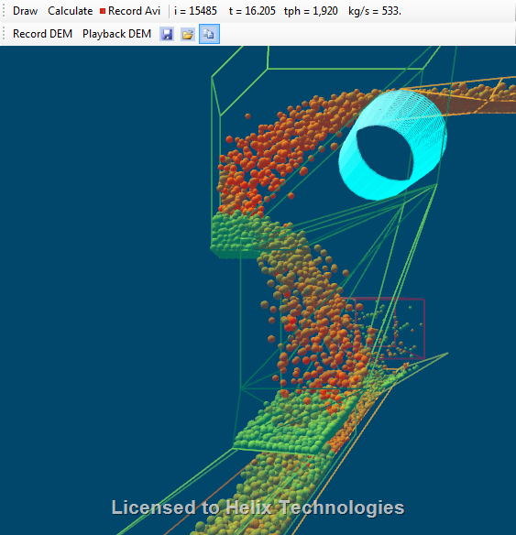

Note a few particles fall from the lip of the wear bar on the rock box all the way onto the lower belt without contacting the chute sides. The energy from these particles will cause ‘boiling’ of the material and they can be seen by the orange colour in the loading area. The majority of the particles fall from the upper rock box onto the lip above the left hand side of the CV5 belt. This causes more material to be loaded on the left side of the receiving belt CV5 than on the right hand side. This may cause the belt to run off track towards the right hand side of the idler rollers but the amount is difficult to predict.

View on loading box from receiving belt
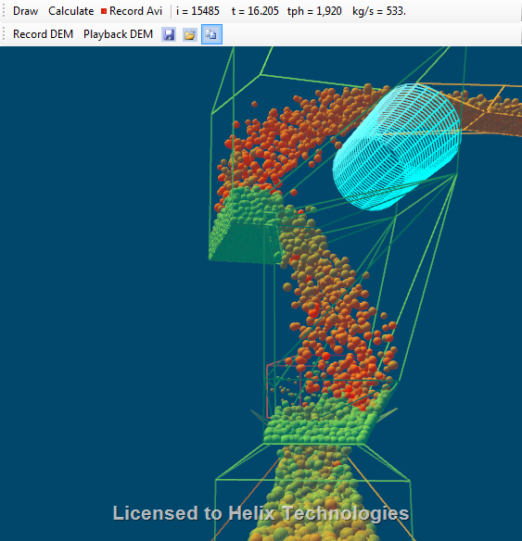

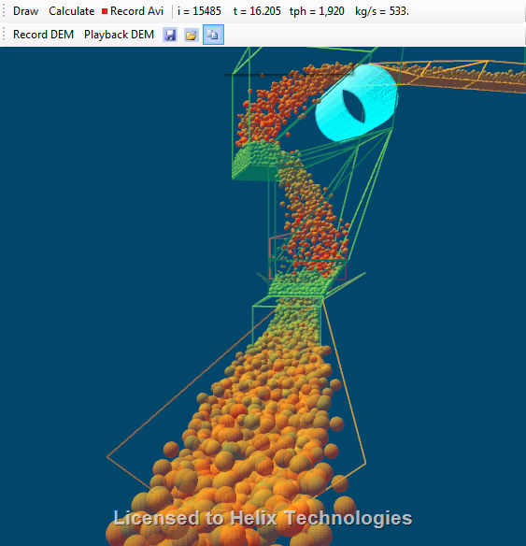
Note slightly more material seems to be on the left hand side of the belt when viewed from the tail end of conveyor (right side in this view). The model has stabilised at approximately 15500 particles after a time of 16.2 seconds has elapsed.

Particle Trace
The Helix DEM software allows the recording of particle positions and velocities. Then particles can be chosen at random and their path through the transfer drawn as a trace.

The image below is a trace of a single, randomly chosen particle in the model. This particle was travelling on the belt surface and is not a lump on the top of the burden.

Particle number 1366 Trace

Side Elevation of Particle 1366 trace
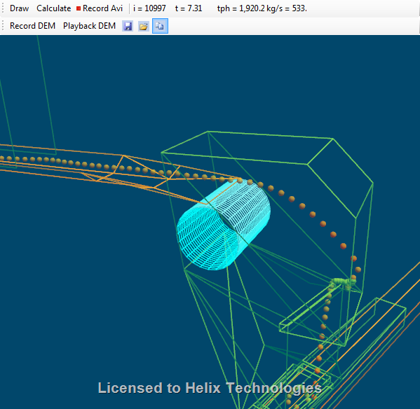

The particle impacts the front face of the chute box. This is slightly higher than the theoretical trajectory calculation which shows the impact to be at -1m below pulley centre line. This difference between theoretical trajectory and DEM calculations has been observed many times and verified by site observation. Refer to the Particle trace report in the appendix for details.
After spending time in the rock-box the particle is ejected by impact energy of following particles and falls over the wear bar on the rock box lip and then impacts directly onto the lower belt, bounces and then follows the other material on the belt.

Front Elevation of Particle 1366 trace
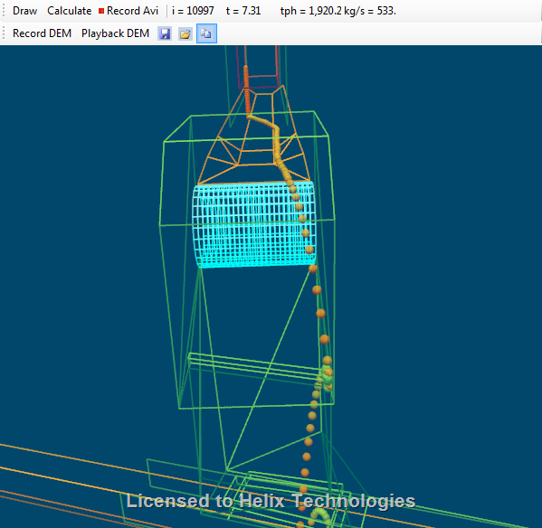
Vertical Impact velocity Vz onto lower belt is 6.3m/s – see page of trace report ‘Helix Chute Andina CV4E-CV5 Particle Trace Report 1366.pdf’.

Summary and Conclusions
The following points have been observed from the DEM Calculations
- Discrete Element Method (DEM) modelling of the transfer shows that it will operate satisfactorily.
- There will be some turbulence caused by material falling directly from the top rock box onto the belt. This can be observed in the video.
- Material already loaded on the belt will be disturbed by the material from CV4E. This will generate dust and material may be forced out from the conveyor skirts – it is recommended that well fitting skirts are utilised and that belt sag on CV5 be limited by using closely spaced impact idlers. This will reduce dust emissions and material spillage.
- The narrowest part of the chute is the Vee slot rock box above CV5. The DEM model does not show the chute blocking or building up excessively but DEM will not show mechanical bridging of slabs or the build up of wet sticky fine material. If wet sticky fine material is to be transported it will tend to build up in the lower Vee slot rock box and blockages may occur here.
- The DEM model shows a slight tendency for material to load more on the left hand side of the CV5 (when viewed from the tail end). This may cause the belt to shift after the loading point.

Reference Drawings and Documents
Description | Drawing Number

Appendices
The following files in electronic file format make up the appendices to this report.

Particle Trace Reports

Helix Chute ABC Mining CV4E-CV5 Particle Trace Report 1366.pdf
Particle trace report from DEM calculations.

Helix DEM Model movie file download links

HelixChuteCV4E-CV5rev01.avi

Click the following link to download a Windows AVI movie file of the conveyor operating at 1600tph with no rear curtain on the chute box. The file is packaged in a zip file.
http://www.helixtech.com.au/ftp/pub/HelixChuteCV4E-CV5TransferRev01.zip

